|  | **BAHRIA UNIVERSITY, (Karachi Campus)**  *Department of Software Engineering*  **Assignment 1 - Fall 2022** |  |
| --- | --- | --- |

COURSE TITLE: **INTRODUCTION TO PSYCHOLOGY** COURSE CODE: **PSY-102**

Class: **BSE-V & III** Shift: **Morning**

Course Instructor: **Marvi Makhdoom** Time Allowed:  **2 Weeks**

Submission Date: 3rd NOV, 2022 Max. Marks: **5 Marks**

**Question No. 1 [CLO1: 5 Marks]**

Students are requested to write about the psychological theory/perspective or school of thought that they think best define human behavior or mind. You should come up with the evidences, real life examples or past researches to back up your claim/s. (Min 200- 400 words)

**Answer**

Each approach has its strengths and weaknesses, and brings something different to our understanding of human behavior.  For this reason, it is important that psychology does have different perspectives on the understanding and study of human and animal behavior.

## Behaviorist Perspective

If your layperson's idea of psychology has always been about people in laboratories wearing white coats and watching hapless rats try to negotiate mazes in order to get to their dinner, then you are probably thinking about [behavioral psychology](https://www.simplypsychology.org/behaviorism.html).

## Psychodynamic Perspective

Who hasn't heard of [Sigmund Freud](https://www.simplypsychology.org/Sigmund-Freud.html)? So many expressions of our daily life come from Freud's theories of psychoanalysis - subconscious, denial, repression and anal personality to name only a few.

Freud believes that events in our childhood can have a significant impact on our behavior as adults. He also believed that people have little free will to make choices in life. Instead, our behavior is determined by the unconscious mind and childhood experiences.

## Humanistic Perspective

[Humanistic psychology](https://www.simplypsychology.org/humanistic.html) is a psychological perspective that emphasizes the study of the whole person (know as holism).  Humanistic psychologists look at human behavior, not only through the eyes of the observer, but through the eyes of the person doing the behaving

## Cognitive Perspective

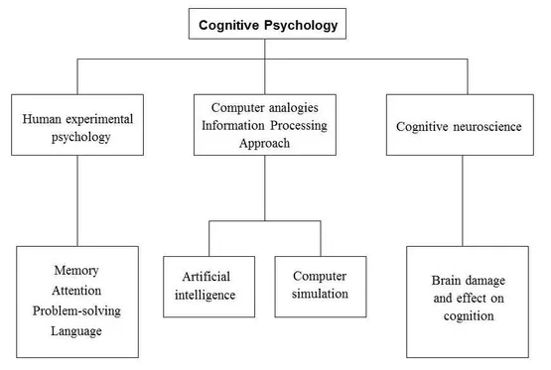

## Biological Psychology:

The biological perspective states that all thoughts, feeling & behavior ultimately have a biological cause. It is one of the major perspectives in psychology and involves such things as studying the brain, genetics, hormones, and the immune and nervous systems.

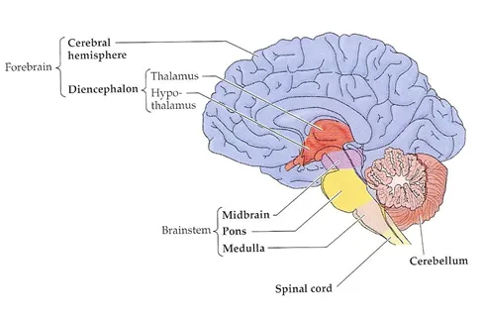

**MY POINT OF VIEW:**

According to me the psychological theory/perspective or school of thought that they think best define human behavior or mind is Behavioral Perspective. The behavioral perspective belongs to a school of thought known as Behaviorism or Behavioral theory.

**BASIC EXPLANATION:**

Many philosophers, scientists and biologists have long sought to answer a simple question: What motivates human beings? What can explain our decisions, actions and behavior? According to the behavioral perspective, the way we behave and learn can be explained through our interactions with the environment. Our actions are always responses to stimuli, which either occur naturally or because of a learned response.

Behavioral theory is the overarching analysis of human behavior focused on examining a person’s environment and learned associations. Behaviorism suggests that all behavior is acquired through conditioning and can therefore be observed without consideration of thoughts or feelings. Since all behavior is but a response, behaviorism also suggests that anyone can learn to perform any action with the right conditioning. Instead of attributing talents, skills, or behaviors to genetics, personality, or cognition, behaviorists believe them to be simply a product of conditioning.

**Examples Of Real Life**

## Positive Reinforcement:

1. The teachers reward their class or certain students with a party or special treat at the end of the week for good behavior throughout the week.

## A student gets a small treat if they get 100% on their spelling test. In the future, students work hard and study for their test in order to get the reward.

## Negative Reinforcement

1. Employees who don't meet their weekly sales quota are required to submit a report explaining why they missed the quota and what they will do differently next week. An employee who dislikes writing reports may be motivated to work harder to make their quota to avoid having to write a report.
2. Ahmed's mother gets angry and yells at him when he forgets to do his chores. He doesn't want to get yelled at, so he makes a point of remembering to complete his chores

## Punishment:

1. Student-athletes are required to maintain at least a grade of a B in every class in order to participate in their various sports. If a grade drops below a B, the athlete will not be allowed to compete until he or she improves the grade. The punishment of having to sit out of games can motivate students to quickly do what is needed to improve his or her grade.
2. If a high school student is late to school more than three times in a marking period, he or she will earn a detention and have to stay after school. School officials hope that the possibility of having to serve time in detention will encourage students to arrive at school on time

## Conclusion

Human behavior is a multi-faceted and dynamic field of study, requiring many points of interrogation to yield insights. Learning processes lay the foundation for determining many of our behaviors, although we are constantly changing in response to our environment.